EMBARGOED FOR RELEASE: CONTACT: Kylie Carlino, 202-596-1680 March 9, 2021 Kylie.Carlino@Regnery.com

“No More Lies. My Grandfather Was a Nazi.”

“Silvia’s grandfather was the perpetrator that slaughtered a majority of my relatives. . . . Silvia Foti is an amazing woman. She is standing up against a machine of lies.”—Grant Gochin, Lithuanian Jewish American

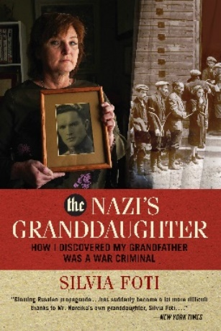
Washington, D.C.—What would you do if you found out that your war-hero grandfather was not a hero—instead, he was responsible for the deaths of eight thousand Jews? The Nazi’s Granddaughter: How I Discovered My Grandfather Was a War Criminal is Silvia Foti’s account of her wrenching, twenty-year investigation that not only reshaped her family history but also exposed an official cover-up by the Lithuanian government that resulted in an internationally followed lawsuit. Her discovery has undone a national narrative in Lithuania which converted Holocaust villains like Silvia’s grandfather into war heroes.

Silvia made a deathbed promise to her mother to write a book about her famous, WWII hero grandfather, Jonas Noreika. Silvia’s grandmother begged her not to write about her husband. “Just let history lie,” she whispered. Silvia had no idea that in keeping her promise to her mother, her discoveries would bring her to a personal crisis, challenge her Catholic faith, unearth Holocaust denial, and expose an official cover-up by the Lithuanian government.

Silvia was raised on reverent stories about her hero grandfather, a martyr for Lithuanian independence and an unblemished patriot. Jonas Noreika, remembered as “General Storm,” had resisted his country’s German and Soviet occupiers in World War II, surviving two years in a Nazi concentration camp only to be executed in 1947 by the KGB. His granddaughter, growing up in Chicago, was treated like royalty in her tightly knit Lithuanian community. But in 2000, when Silvia traveled to Lithuania for a ceremony honoring her grandfather, she heard a very different story—a “rumor” that her grandfather had been a “Jew-killer.” As she dug ever deeper, she “encountered so much evidence proving my flesh and blood ‘hero’ was a Jew-killer, even I could no longer believe the lie.”

This disturbing story begs questions of Silvia and her readers:
- How should our family’s past, shameful or noble, shape our identity?
- How could one man be revered as a hero, having a grammar school named after him, and yet be a villain responsible for the deaths of thousands?
- Why are some European countries still in denial about their role in the Holocaust?
- How was this kept secret until now?
The Nazi’s Granddaughter by Silvia Foti is available March 9, 2021, in hardcover (400 pp, $26.99, 978-1-68451-108-2) from Regnery History, www.regneryhistory.com.
The Nazi’s Granddaughter
By Silvia Foti

LITHUANIAN GOVERNMENT CONTINUES TO PERPETRATE HOLOCAUST REVISIONISM
—Entry on “The Storm Door Blog” by Silvia Foti, February 2021

While my grandfather’s role in the Holocaust has been painful enough to discover, what has been equally painful was the discovery of the Lithuanian government’s denial of his role in the Holocaust. This is the 10th stage of genocide—Denial that it ever happened. In this case, Lithuania can’t deny that the Holocaust happened on its land. But it has been denying its own role in the annihilation of 96.4 percent of its Jews. Since then, I’ve decided to stand up and speak out. . . .
[The] Israeli-American Civic Action Network (ICAN) has launched an issue education initiative to ensure all 535 members of the United States Congress learn about the ongoing Holocaust revisionism campaign perpetrated by the Lithuanian government.
“The Republic of Lithuania is engaged in a cynical, dishonest, and morally bankrupt campaign to deny and distort facts about the Holocaust. Facts supported by indisputable evidence, which proves that Lithuanians engaged in Holocaust crimes on a massive scale,” said Dillon Hosier, CEO at ICAN.
“The Lithuanian government not only hides the criminal histories of Holocaust perpetrators but adds insult to injury by bestowing their highest national honors to those who are proven murderers of Jews,” Hosier concluded. “If the Lithuanian government is able to effortlessly lie about history’s greatest crime, then it begs the question: what won’t they lie about?”
On three separate occasions dating back to February 26, 2018, the Genocide and Resistance Research Center of Lithuania (LGGRTC) falsely claimed that the United States Congress and the United States Immigration and Naturalization Service (INS) “completely exonerated” Juozas Ambrazevičius-Brazaitis for culpability in the murder of Jews in Lithuania. In response to inquiries and objections from senior members of Congress about these false claims, Lithuania responded that these members of Congress were “just politicians” and that their opposition has no merit.
ICAN’s initiative to educate Congress about Lithuania’s campaign to deny and distort certain facts about the Holocaust will be launched alongside the publication of “The Nazi’s Granddaughter: How I Discovered My Grandfather was a War Criminal” written by Silvia Foti, available on March 9, 2021. . . .
In her book, Foti chronicles the story of how she discovered her grandfather, revered as a famous war hero by the Lithuanian government, was in fact a Nazi war criminal. ICAN plans to send every member of the United States Congress a copy of this book to illustrate just one singular example of Lithuania’s Holocaust distortion campaign. ICAN will also be encouraging and supporting Federal legislation to address Lithuania’s Holocaust frauds.
This campaign is being conducted in partnership with ICAN’s educational affiliate, the Israeli-American Civic Education Institute, a 501(c)(3) charitable nonprofit organization. For more information about this campaign, please visit http://bit.ly/holocaustbook.

To schedule an interview with Silvia Foti, please contact Kylie Carlino at
Kylie.Carlino@Regnery.com or 202-596-1680
The Nazi’s Granddaughter
By Silvia Foti
QUESTIONS FOR THE AUTHOR

The Nazi’s Granddaughter Questions:

- What were you told about your grandfather when you were growing up?
- What caused you to decide to write this book?
- What happened in October 2000 when you were visiting the school named after your grandfather?
- Many family members would have decided to drop the project. Why did you continue?
- Once you decided to move forward, what did you discover to substantiate the rumor?
- This must have affected your identity as a proud Lithuanian. How did you feel?
- This is a very complicated story and seems like it was so difficult to tell. You explain that it took you twenty years to write. As a writer, what did you do to prepare to write this story, and why did it take so long?
- You were in Lithuania for seven weeks in 2013 to research the rumor about your grandfather. What were some of the highlights?
- You discovered something interesting about your grandparents’ wedding. Would you like to talk about it?
- With the publication of The Nazi’s Granddaughter, you have become a speaker and an activist on Holocaust distortion. What do you hope to accomplish?
Religious Questions:

- You are a practicing Catholic. How did your faith play a role in pursuing this story?
- How do you view your grandfather today?
- How does this impact interfaith relations between Jews and Catholics?
- When you were in Lithuania, you visited the Our Lady of Siluva (Shiluva) shrine. Why did you go there, and what happened while you were there?
- Also while in Lithuania, you visited the Samogitian Calvary (or Zamaiciu Kalvarija), a pilgrimage site for Catholics. How does this connect to your story and what happened while you were there?
- You refer to “the Worrier” in your book, a figure of Christ. What can you tell us about that figure and how does it connect to this story?

To schedule an interview with Silvia Foti please contact Kylie Carlino at
Kylie.Carlino@Regnery.com or 202-596-1680
The Nazi’s Granddaughter
By Silvia Foti
ABOUT THE AUTHOR

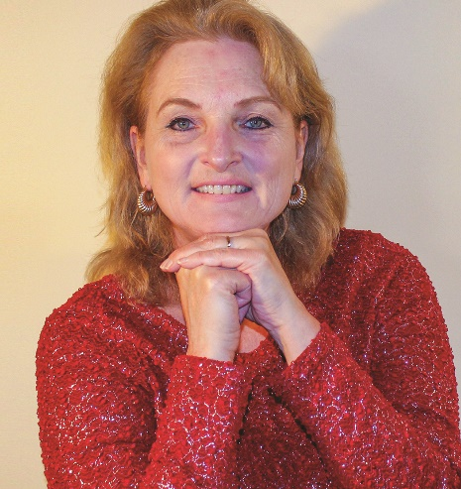
“Analysis of a dark past is always traumatic. But we will never achieve clarity and healing if we base our history on lies.”—Silvia Foti

SILVIA FOTI is an award-winning investigative journalist and English teacher, and she holds master’s degrees in journalism, education, and creative nonfiction. She has been published in the Chicago Tribune, Crain’s Chicago Business, L.A. Parent, Dappled Things, Southtown Economist, Southwest News Herald, Buenos Aires Herald, Argentine News, and Salon.com. Fluent in Lithuanian, English, and Spanish, she lives near Chicago. The Nazi’s Granddaughter is her third book.

AVAILABLE COLLABORATOR

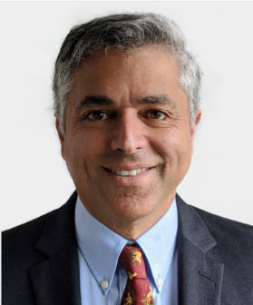
“Silvia’s grandfather was the perpetrator that slaughtered a majority of my relatives. . . . Silvia Foti is an amazing woman. She is standing up against a machine of lies.”—Grant Gochin, Lithuanian Jewish American

Grant Gochin* met Silvia through her research for The Nazi’s Granddaughter. He has investigated and prosecuted Lithuanian leaders who participated in or were complicit in Lithuanian Holocaust activities and the persecution of Lithuanian Jews. He, along with Silvia, has sought to strip genocidal leaders such as her grandfather of state honors. His lawsuit against the Lithuanian government for Holocaust denial and distortion is now before the European Court of Human Rights.

*Gochin is available for joint interviews with Silvia to discuss their mission through the courts to end Holocaust denial, and to educate and equip every member of Congress with The Nazi’s Granddaughter.

To schedule an interview with Silvia Foti, please contact Kylie Carlino at
Kylie.Carlino@Regnery.com or 202-596-1680

